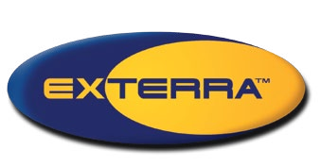 

**SHUT TERMITES OUT**

**W I T H O U T C H E M I C A L S**

**SHUT TERMITES OUT**

**W I T H O U T C H E M I C A L S**

Do you Really Want Toxic Chemicals Around Your Home?

**The EXTERRA Termite Interception and Baiting System** has established itself as the elite standard in termite elimination. EXTERRA is founded on solid scientific fact. EXTERRA has remained true to the science, by exploiting the biology of termites in a manner no other system matches. While the EXTERRA system focuses on TOTAL termite colony elimination, guaranteeing the most effective results, other systems focus on the use of harmful chemicals, cutting costs and cutting corners at the expense of premium performance and the TOTAL elimination of termites.

Termites live in large underground colonies, and you want all

the colony members dead, otherwise they will come back at some time in the future to do further damage.

We think it’s just common sense that you should only be satisfied once all the colony members are dead.

Considering the serious amounts of damage that termites do, we believe you should settle for nothing less than the

TOTAL elimination of their colony.

References

1. Su et al Journal of Economic Entomology (2005) - Response of the Formosan Subterranean Termites (Isoptera: Rhinotermitidae) to Baits or Non-repellent Termiticides in Extended Foraging Arenas.
2. Osbrink et al Journal of Economic Entomology (2005) - Effect of Imidacloprid Soil Treatments on Occurrence of Formosan Subterranean Termites (Isoptera: Rhinotermitidae) in Independent Monitors.
3. Peters et al International Conference On Urban Pests (2005) The EXTERRA Termite Interception And Baiting System In Australia,Thailand And The Philippines. Peters et al International Research Group On Wood Preservation (2005) Evaluating The EXTERRA Termite Interception And Baiting System In Australia. Garcia et al International Research Group On Wood Preservation (2007) Termite Baiting System: A New Dimension of Termite Control in the Philippines.

Peters et al International Conference On Urban Pests (2008) Evaluating a Baiting System for Management of Termites in Landscape and Orchard Trees in Australia, Hong Kong, Malaysia and the Philippines.

Sukartana et al Journal of Tropical Forest Science (2009) Evaluation of Chlorfluazuron in Controlling the Subterranean Termite Coptotermes curvignathus (Isoptera: Rhinotermitidae) In Indonesia.

## Chemical termite treatment does NOT kill all the colony

**Liquid Chemical Treatments**

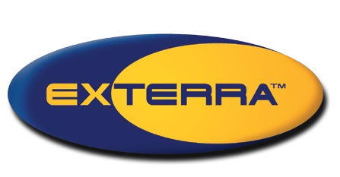Do you really want hundreds, or thousands, of litres of toxic chemical sprayed around your home?

## EXTERRA -

**TOTAL termite colony elimination**

**EXTERRA Eliminates the Colony**

EXTERRA uses REQUIEM Termite Bait in a closed and locked Station, providing greedy termites with

**When you install the environmentally friendly Exterra Termite Interception and Baiting System, you will be supporting Australian Wildlife Conservancy and securing vital habitat for Australia’s threatened wildlife.**

The World’s Most Effective Termite Baiting System

**TOTAL TERMITE COLONY ELIMINATION**

&

The manufacturers require that 5 L of liquid chemical is sprayed to each square metre of soil.

That is a lot of toxic chemical!!!!

their “Last Supper”. The termites take the REQUIEM

Termite Bait back to the nest. The colony is eliminated and your home is safe.

partners for life

**More than $500,000 has been donated by EXTERRA for wildlife conservancy.**

## Make Sure the Job Gets Totally Done

**S H U T T E R M I T E S**

**O U T**

**W I T H O U T C H E M I C A L S**

Most termite control products can get the termites out of your house and kill lots of termites in the ground, yet still leave the termite colony lurking under your home.

## EXTERRA is Less Toxic Than Salt

With EXTERRA the problem of termites is solved by the application of termite bait containing less than ¼ of a gram of an active ingredient less toxic than table salt!

For more information go to: [www.australianwildlife.org](http://www.australianwildlife.org/)

**w w w . e x t e r r a . c o m . a u**

**™** Trademark of Ensystex, Inc.

BROE1036 2.01 07.13



How EXTERRA Eliminates Termites

How EXTERRA Eliminates Termites

**The EXTERRA Termite Terminal**

**EXTERRA - Scientifically Proven Colony Elimination**

Under carefully controlled conditions designed to simulate what occurs when **liquid chemicals** are applied around your home, one independent scientific study¹ concluded that one of the most widely advertised termite control chemicals killed only 25% of the worker termites

- the type of termite colony member responsible for all the damage done to homes! Another independent

scientific study² involving another widely advertised liquid applied termite control chemical concluded that it had little, if any, effect on termite colonies!

When it comes to termite control, we believe there is only one gold standard. Total termite colony elimination, backed up by several peer-reviewed scientific papers³, that prove EXTERRA eliminates the entire termite colony.

# EXTERRA uses REQUIEM™ Termite Bait in a closed and locked Station, providing greedy

**termites with their “Last Supper”. The termites feed on the REQUIEM and take it back to the nest. The colony is eliminated and your home is safe.**

Without Chemicals

**SHUT TERMITES OUT**

**W I T H O U T C H E M I C A L S**

**There are no invasive processes that require the application of hundreds of litres of toxic spray under and around your home. With EXTERRA the problem of termites is solved by the application of termite bait containing less than ¼ of a gram of an active ingredient less toxic than table salt!**

Treat Termites at their Source and Finish Them Off. For good.

The EXTERRA Termite Interception Zone Secures your home

**With EXTERRA, Stations with**

**FOCUS Termite Attractant™ are discretely placed around your home.**

The FOCUS evolves the gaseous attractant that termites adore over a 2 m radius. Thus, when the EXTERRA Stations are placed around your home, they link together to form the EXTERRA Termite Interception Zone**™**, protecting your home. EXTERRA then does its job naturally by directing termites to the Stations and not to your home.

## As this diagram above demonstrates, your home is securely protected by the complete and

The Facts on Termite Management

**continuous EXTERRA Termite Interception Zone.**

**NO GAPS FOR TERMITES TO PASS THROUGH**

When using liquid products, your pest manager MUST create a barrier that is complete and continuous.With liquid chemical treatments it is therefore ESSENTIAL that the pest manager dig a trench around your property. This is then flooded with large volumes of the liquid chemical. After this it needs to be back-filled with soil and additional chemical. This is expensive and time consuming. Of course sometimes pest managers don’t do this and they give you an even less effective treatment!

Furthermore, you need to keep well away while all this is going on.

You’re getting ready to make an important decision. You’re going to choose what you believe is the best way to protect what is probably your biggest investment, your home, against termites.

This decision is made more difficult by the differences between how various termite control products are applied and how they work.

So again some companies drill fewer holes and you get even less of a treatment, since there are gaps remaining for termites to get through. This means your home is not properly protected and you are wasting your

hard-earned money. As you don’t know what is underneath the concrete, you don’t even know where the chemical went. Trials have shown the chemical often doesn’t travel very far!

EXTERRA uses In-concrete Stations to ensure an effective protective barrier around your home is complete and unbroken.

**Chemicals Create a Lot of Gaps for Termites to Get Through**

Many properties are surrounded by concrete paths or aprons. This requires further extensive chemical treatment. Ideally the pest manager should cut away

the concrete around your building and flood the soil as we described previously. Of course this is difficult and expensive to do, so usually the pest manager just drills holes through the concrete, and then injects chemical through the holes which are later sealed up. The manufacturers advise that these holes need to be drilled every 150 - 300 mm. That’s a lot of holes and a lot of expense for you.

**Anything Less than 100% Total Colony Elimination isn’t ‘Gone for Good’**

Even the most widely advertised liquid applied termite control chemicals come up short when it comes to the extent of their effect on a termite colony.

Sure, they can kill the termites that are in your home now, and a lot of the termites in the ground under it, but they haven’t been demonstrated to eliminate entire termite colonies in the ground where they originate.

The creation of the EXTERRA Termite Interception Zone ensures that protection is ongoing, where as chemical deposits age in the soil and breakdown.

This means chemicals eventually reach a point where they no longer affect the termites, and once more the termites return to attack your home.

There is not one published, peer reviewed scientific paper demonstrating colony elimination of our economically important local termite species with any liquid applied termite control product on the market today.

In fact the performance claims on the registered product labels for these liquid chemicals (claims which have

to be supported by trial data for review and approval by leading, independent scientists) make no claim whatsoever regarding colony elimination!

## The FOCUS Termite Attractant releases CO² into the soil, creating a protective barrier and luring termites into their “Last Supper”

**Chemical termite treatment has several shortfalls when compared to EXTERRA**

**Installing liquid chemical treatments**

**Installing EXTERRA**

**EXTERRA requires no invasive processes during installation, usage or maintenance**

Holes are drilled and filled with chemicals

CONCRETE

SLAB

**Holes filled back up**

CONCRETE

SLAB

Rubber Seal

Stainless Steel Plug

CONCRETE

SLAB

Rock blocking Chemical path

**CHEMICAL TREATMENTS PRODUCE UNPROTECTED GAPS FOR TERMITES TO PASS THROUGH**

**UNDERGROUND UNDERGROUND**

Mesh

Timber

FOCUS

Termite Attractant

**UNDERGROUND**

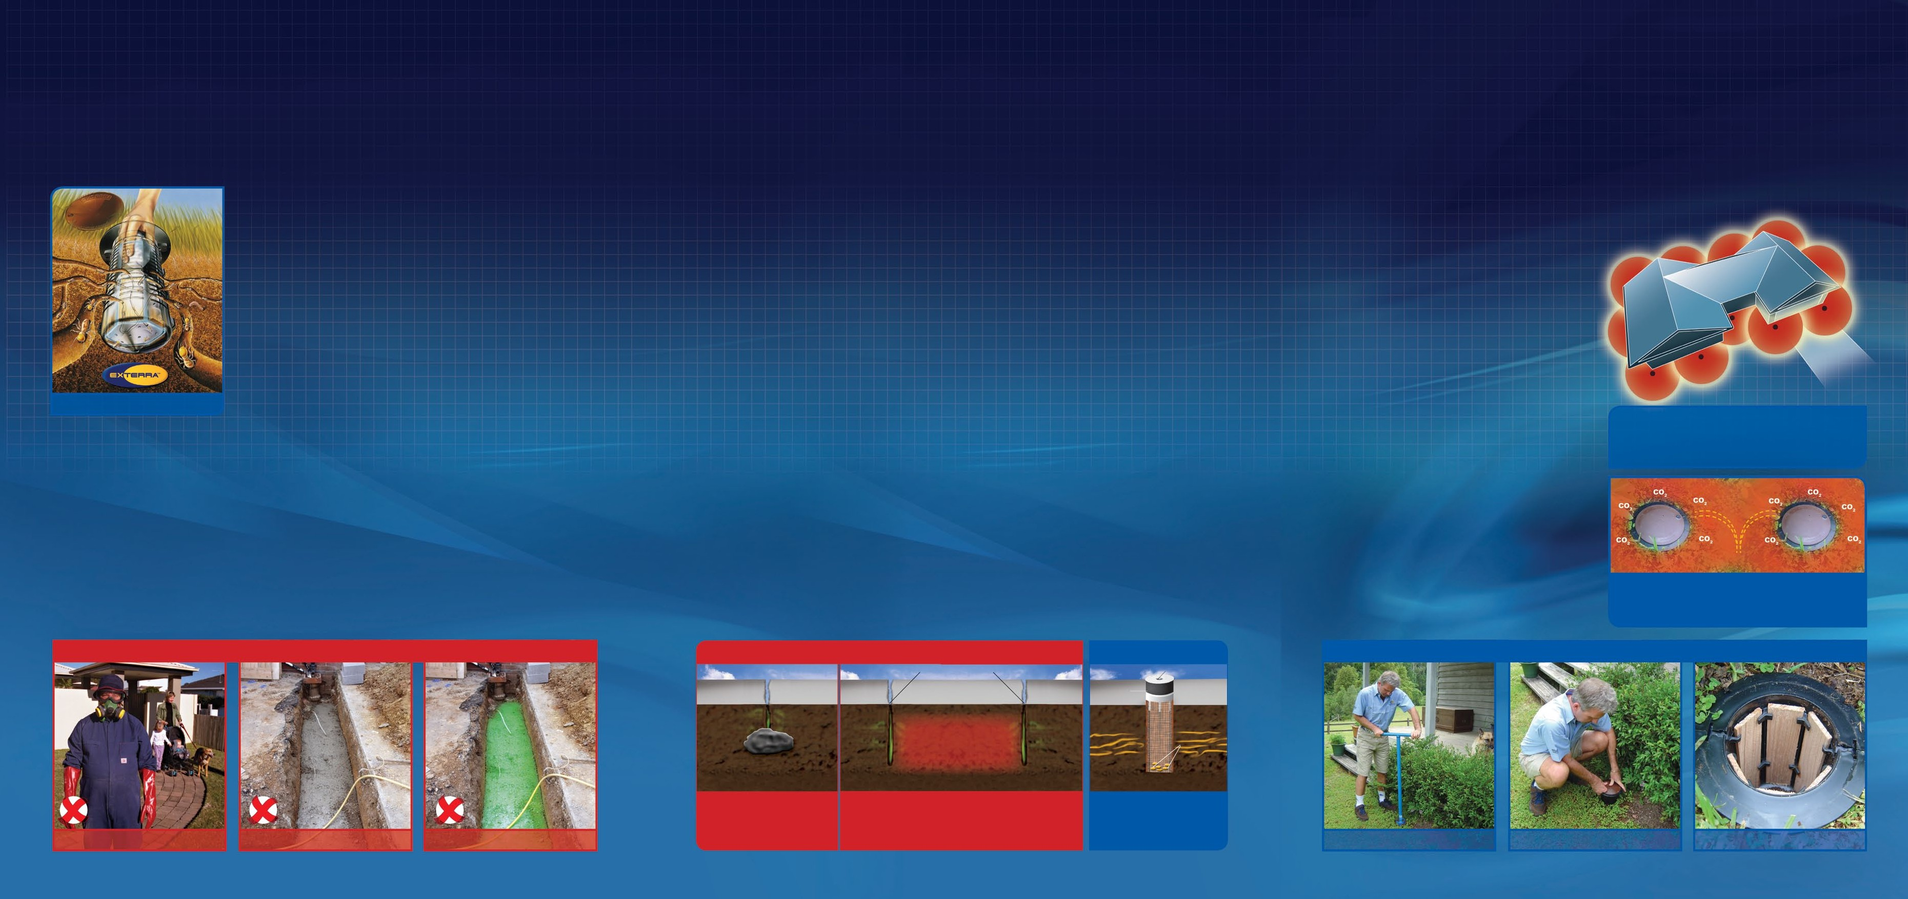

Without Chemicals

**You must keep away from your home A trench must be dug all around your home Filled with chemicals and back-filled**

Holes are drilled into the concrete and filled with chemicals.The path to the soil is NOT always clear causing the treatment to be less effective.

Only the areas which chemicals are injected offer protection. This treatment produces massive gaps for termites to pass.

Instead of chemicals, EXTERRA utilises advancements in CO2 technology to create a continuous protection zone.

An EXTERRA In-ground Station is placed underground,

capped with a Stainless Steel Plug and sealed with rubber.

**EXTERRA - Safe & easy to install Stations are placed around your home The FOCUS Attractant lures termites**